# Ansible Compliance & Remediation Playbooks

This repository contains Ansible playbooks and support files for running system compliance checks and automated remediation for the CDP pre installation tasks.

## Contents

- `compliance_check.yml` - Playbook that reads `controls.csv`, executes checks, and writes a JSON compliance report.
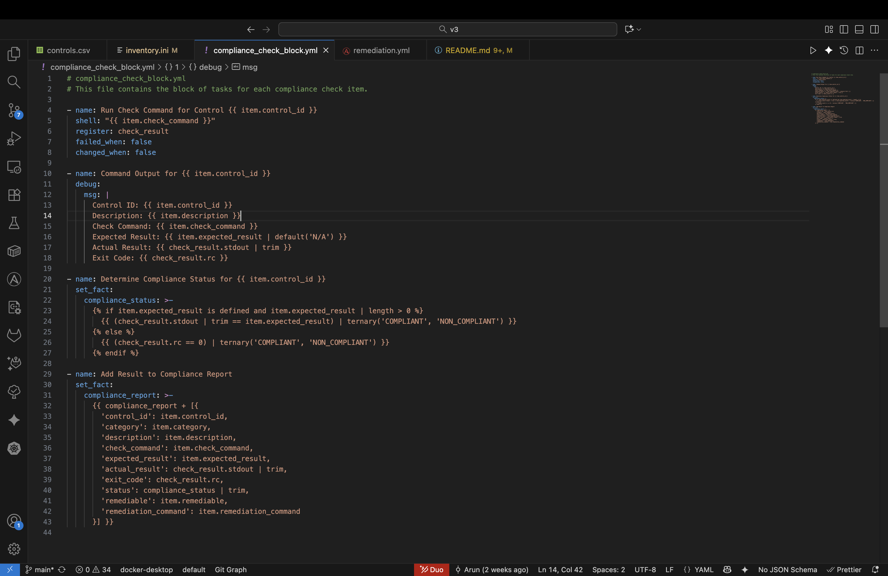
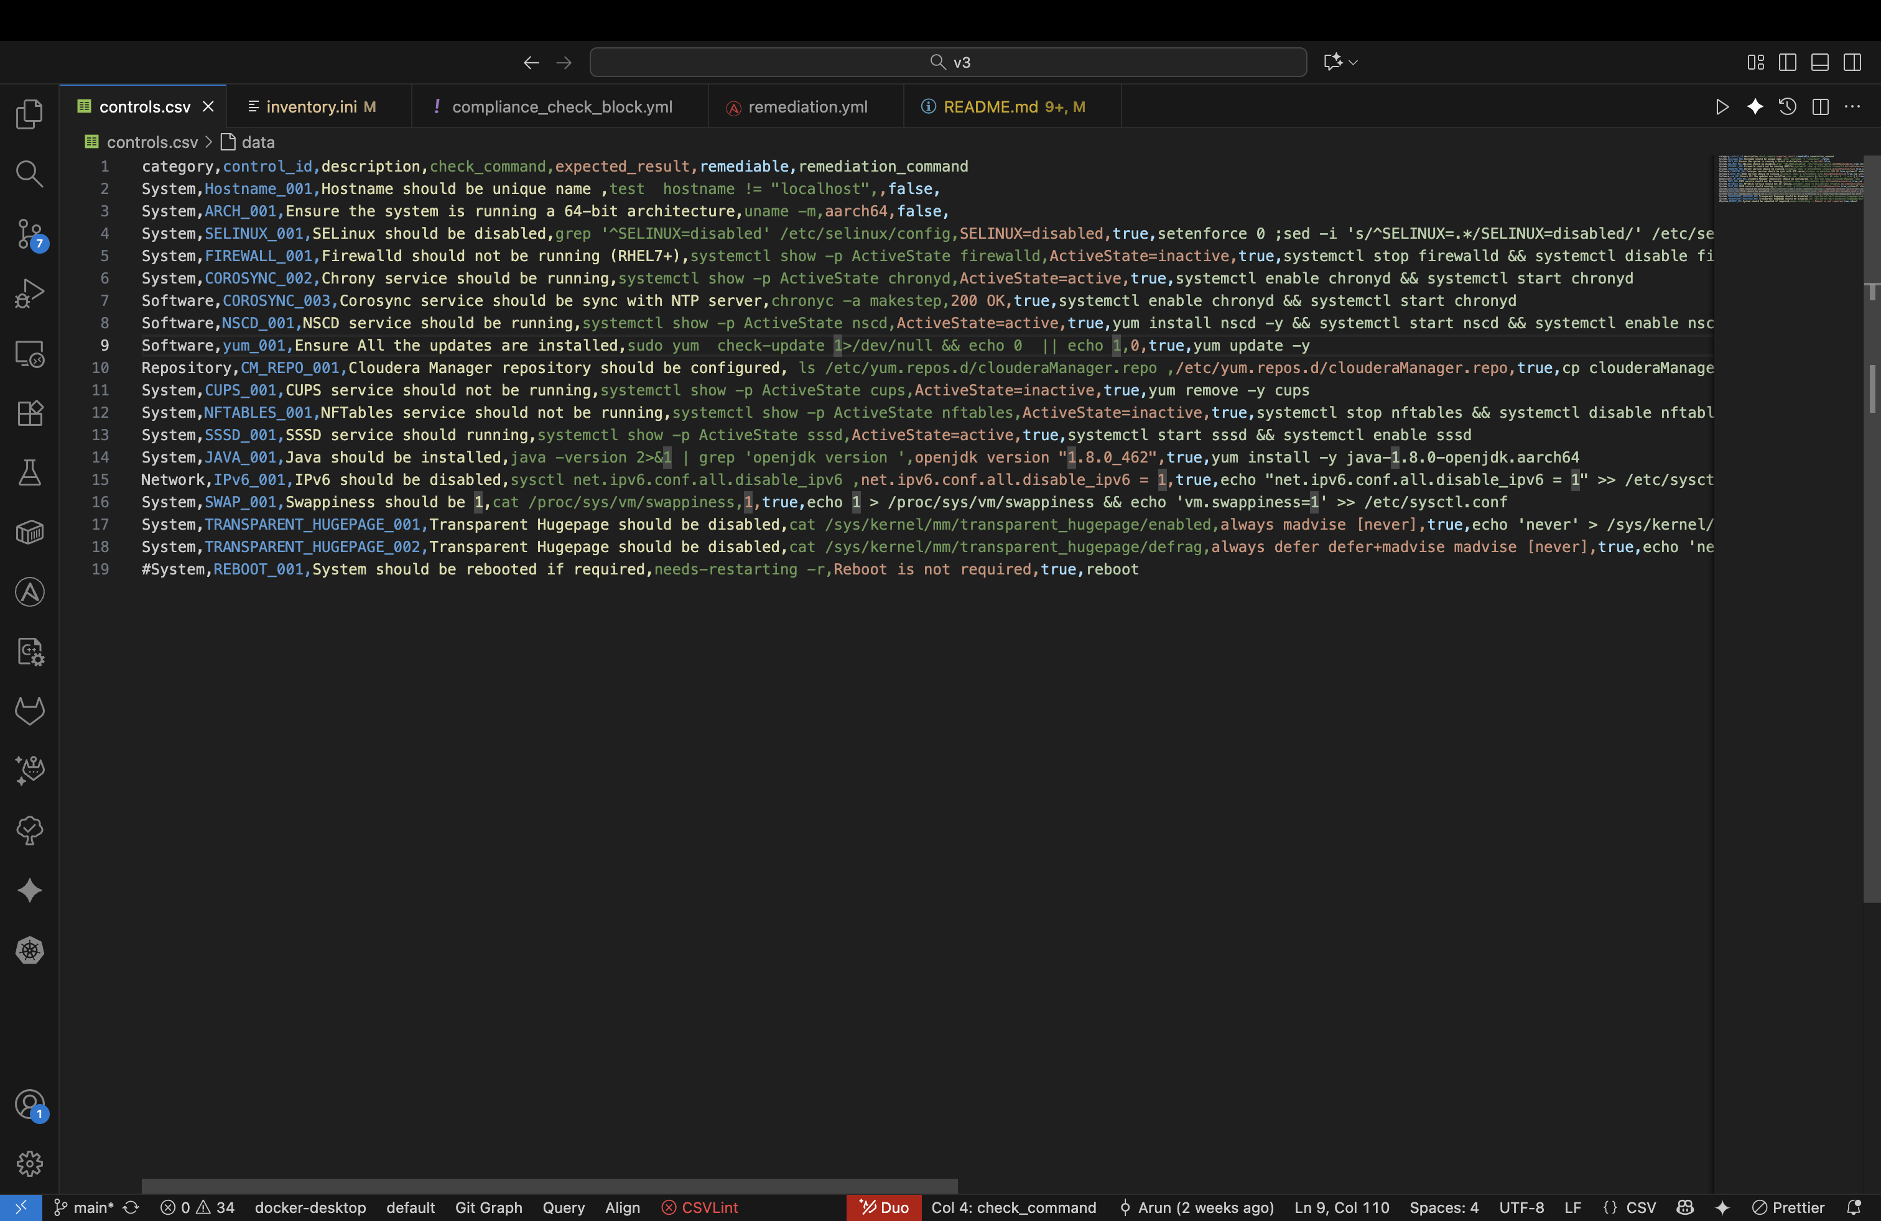

- `remediation.yml` - Playbook that reads a saved compliance report and attempts to remediate items marked `remediable: true`.
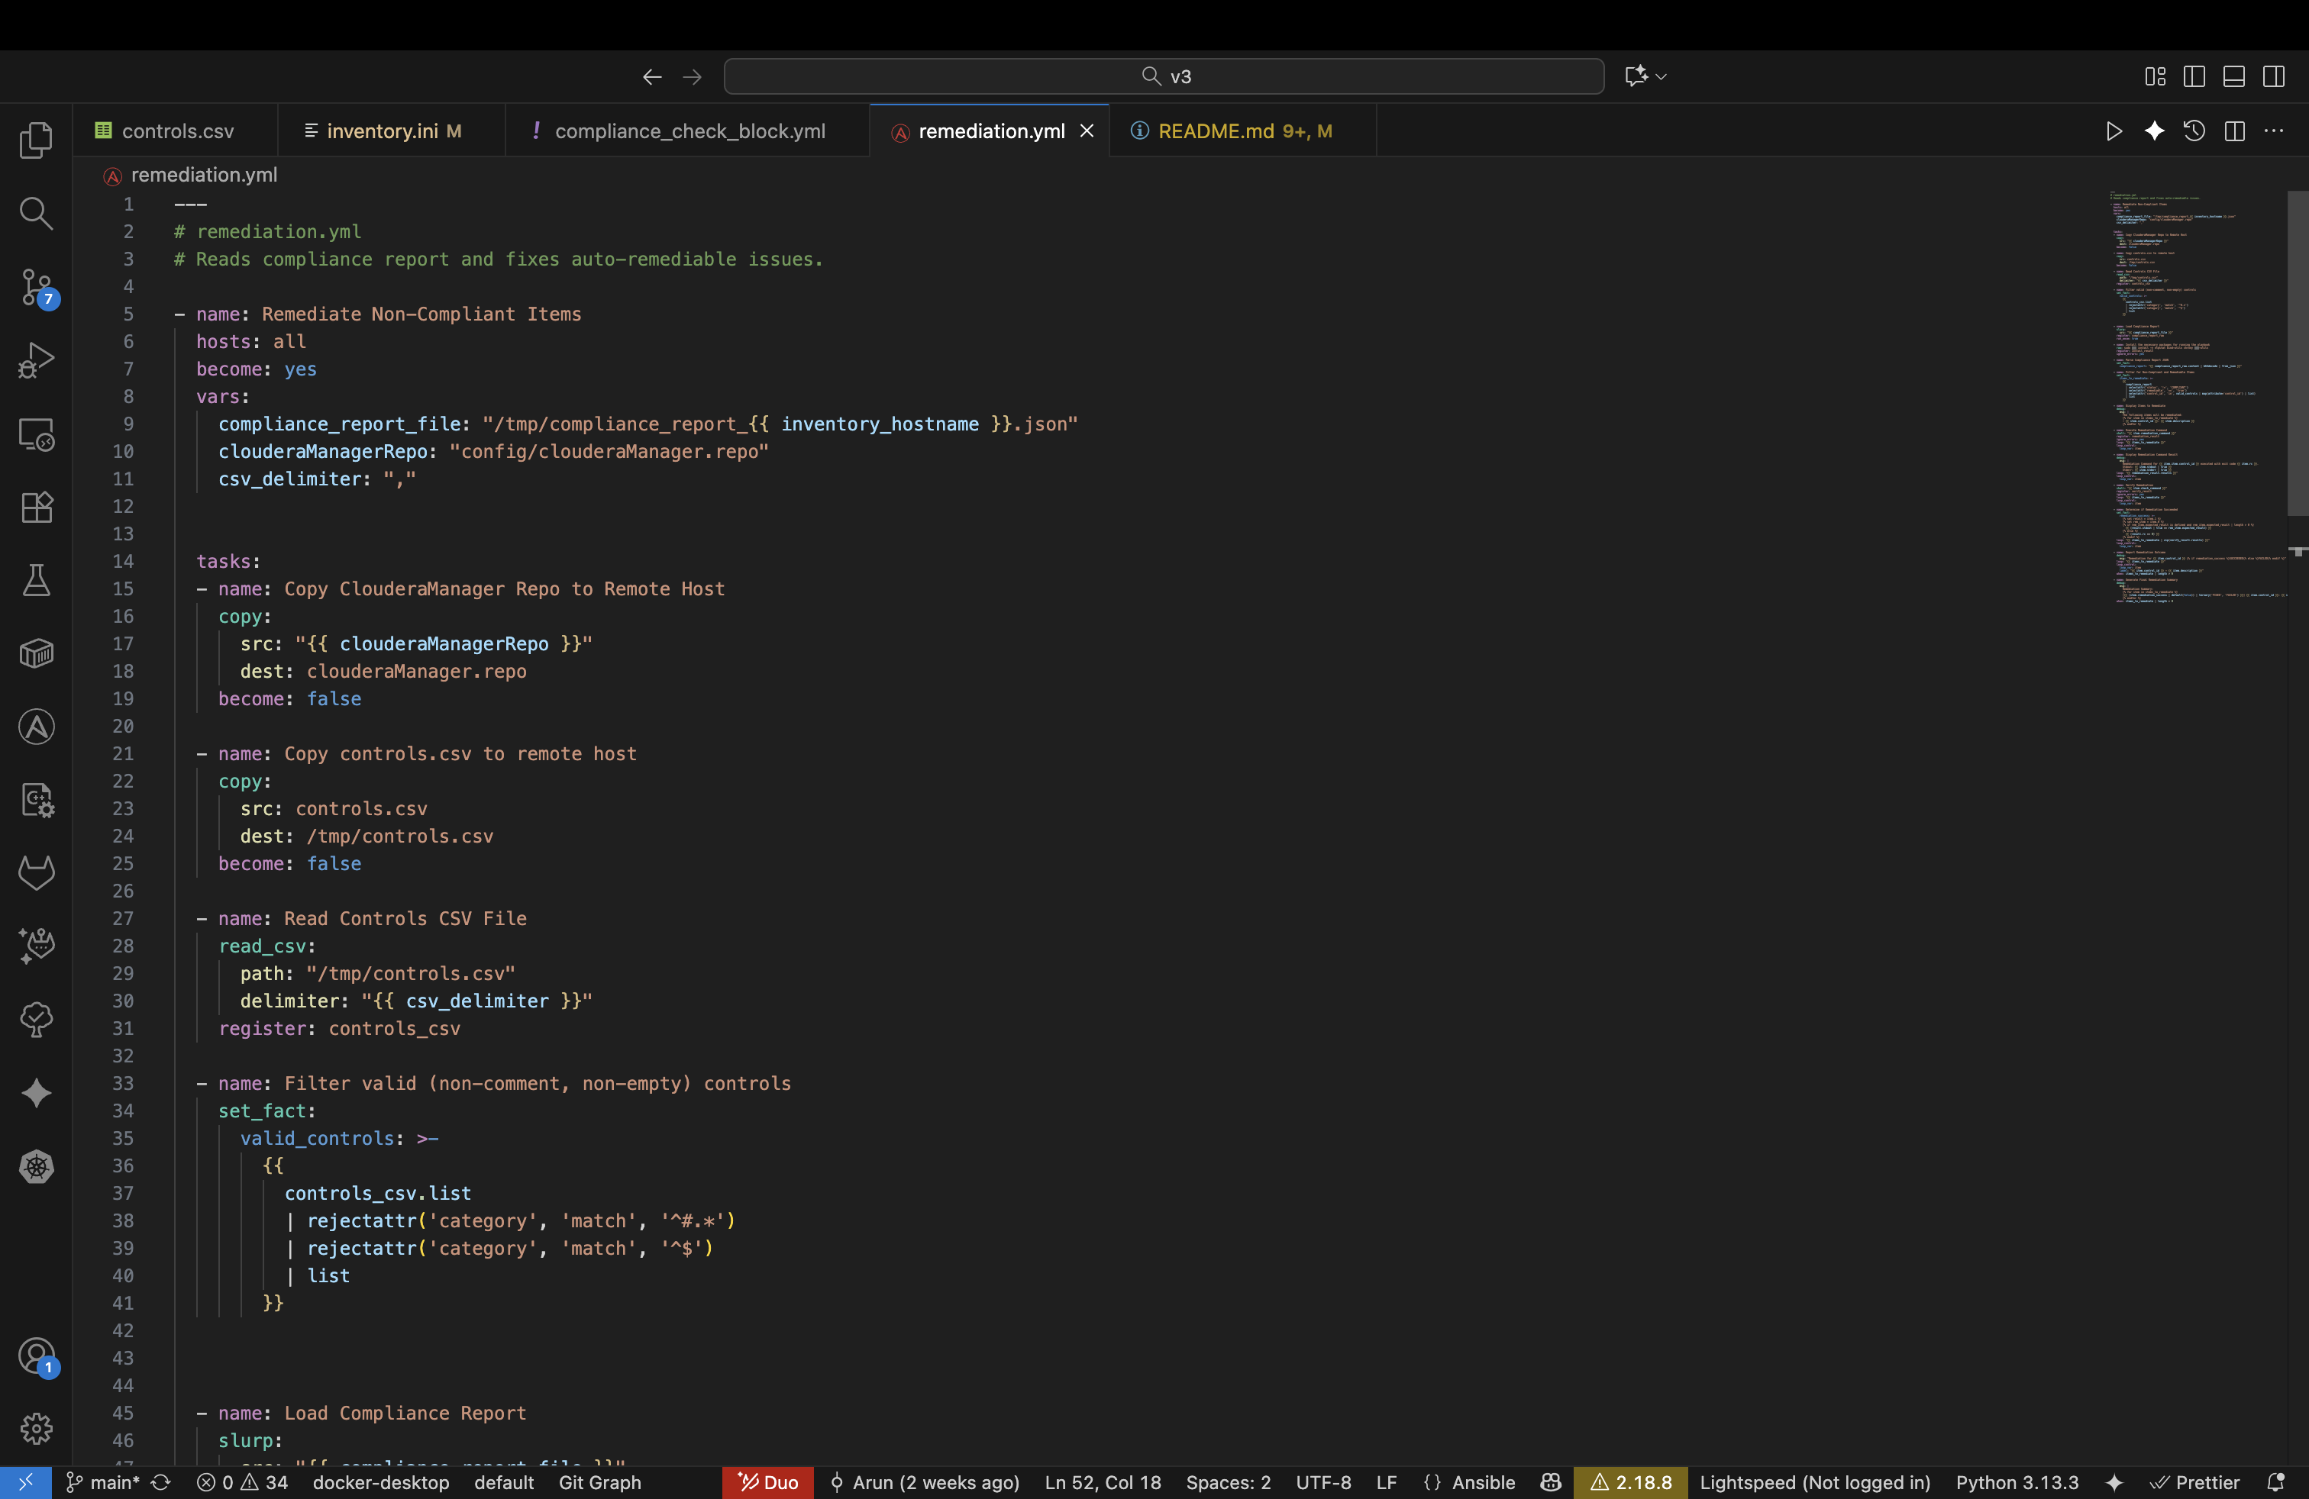

- `controls.csv` - CSV file listing controls and how to check and remediate them.
- `inventory.ini` - Ansible inventory, Contains the host lists where we need to execute tasks against.

## Prerequisites

- Ansible installed on your control node (recommended: ansible-core 2.12+ or latest stable). To check:

ansible --version

- Python 3 should be installed on control node and target hosts.
- SSH access to target hosts with a key or passwordless sudo for the account used by Ansible.
- Ensure `controls.csv` is present in the repo root. The compliance playbook copies this to `/tmp/controls.csv` on target hosts.

## Running the compliance checks

1. Ensure your inventory is correct in `inventory.ini` and SSH connectivity works:

ansible -i inventory.ini -m ping all -u <user>
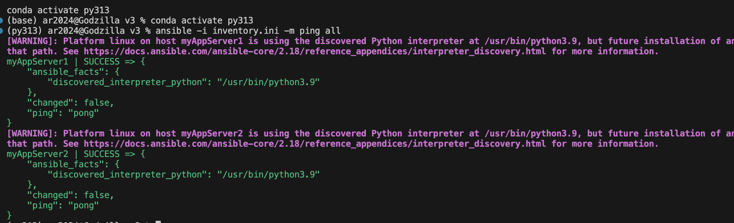

2. Run the compliance check playbook (control node / workspace root):

# run with default inventory
ansible-playbook -i inventory.ini compliance_check.yml

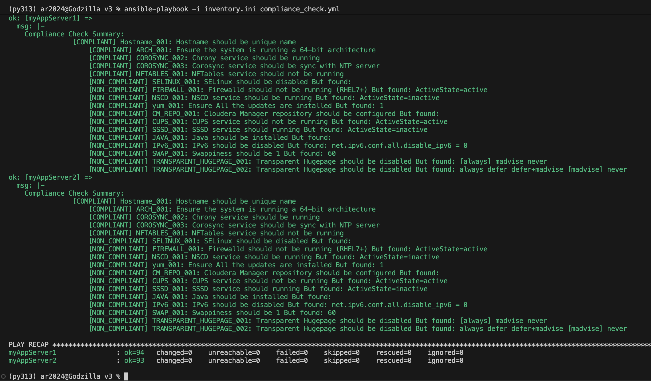

# run with verbose output for debugging
ansible-playbook -i inventory.ini compliance_check.yml -vvv

What it does:
- Copies `controls.csv` to `/tmp/controls.csv` on the target host.
- Runs the checks defined in `controls.csv` (via `compliance_check_block.yml`) and accumulates results in `compliance_report`.
- Writes a JSON report to `/tmp/compliance_report_<hostname>.json` (configurable via variable `cloudera_compliance_report`).
- Prints a sorted compliance summary grouped by status.

Notes:
- The playbook expects results to include `status` and (for non-compliant items) `actual_result` when present.

## Running remediation

After you have a compliance report (created by the `compliance_check.yml` run), run the remediation playbook to attempt automatic fixes for remediable items.

ansible-playbook -i inventory.ini remediation.yml
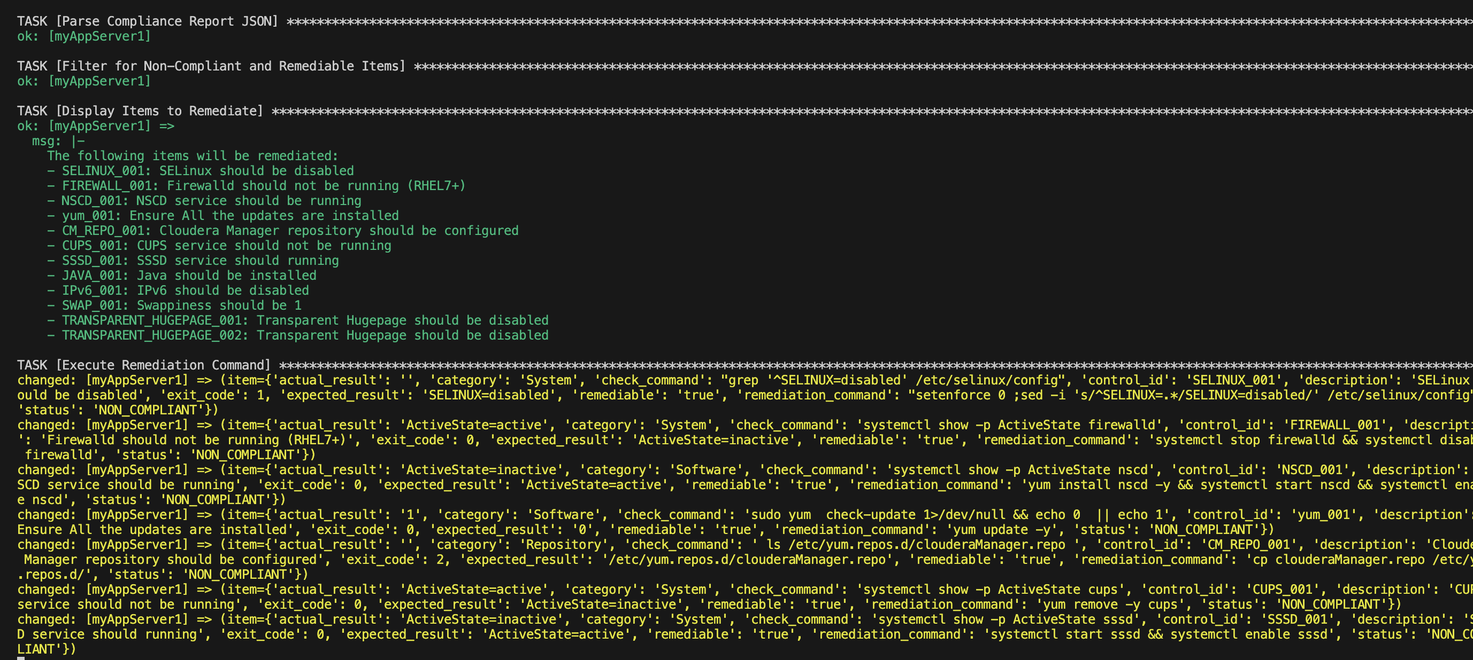

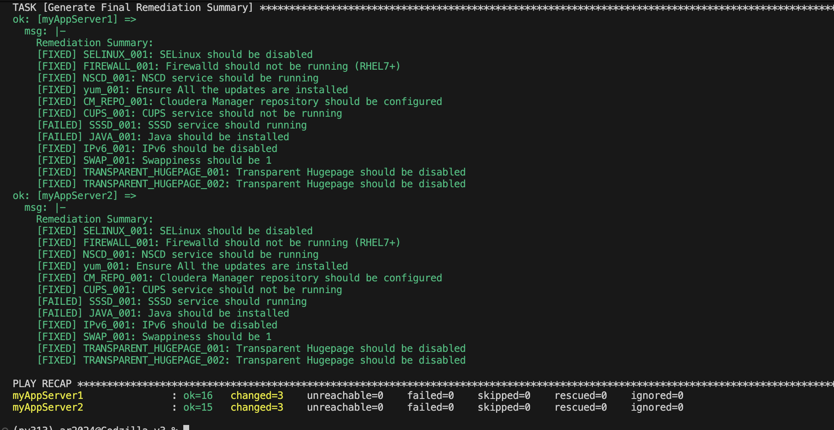

# verbose
ansible-playbook -i inventory.ini remediation.yml -vvv

What it does:
- Loads `/tmp/compliance_report_<hostname>.json` (the playbook reads the file for the host it targets). Ensure the file exists on the controller or has been copied to the remote host as the play expects.
- Filters items with `status != COMPLIANT` and `remediable == true`.
- Attempts remediation commands (the playbook registers and displays results). The playbook now ignores errors for remediation commands so it can continue to attempt further remediations.
- Verifies remediation by running configured check commands and determines success by matching stdout to `expected_result` (or rc==0 when no expected result is configured).

Important reboot behavior:
- If a remediation issues `reboot`, Ansible's SSH connection will drop and the host will be marked `unreachable` until it comes back up. Use the `reboot` module or wrap reboot operations with a `rescue` and wait/reconnect strategy if you want the playbook to resume automatically.

## Example: Run only a single task or tag

If you want to run a single included task file for testing, you can use `--start-at-task` with the exact task name printed by the playbook output. Or run with tags if implemented.

```zsh
# Run starting at a specific task name
ansible-playbook -i inventory.ini remediation.yml --start-at-task "Display Items to Remediate"
```

## Verification / Outputs

- Compliance JSON files are written to `/tmp/compliance_report_<inventory_hostname>.json` by default. Inspect them with `jq` or `python -m json.tool`.

```zsh
ansible -i inventory.ini -m shell -a 'cat /tmp/compliance_report_$(hostname).json' myAppServer
```

